For my final project, I chose to analyze North Carolina's Sex Offense convictions from the North Carolina Sex Offender and Public Protection Registry. (n.d.). The dashboard will allow a user to see conviction rates based on several categories including race, gender, victims’ age, and much more. The purpose of the dashboard is to allow a person(s) to see the total number of offenses in North Carolina. The dashboard will let you analyze data comparing race, gender, age, victim type, year(s) committed, and, finally, show where the crime happened. I used Microsoft's Power BI to create my dashboard. I have found it to be more user friendly for the end user, there are a broad choice of visualizations to use, and it is easier to create and align the dashboard with the many functions that Power BI has at your disposal.

The dashboard is split up into two different parts, a filters section, and the visualization section as shown in Figure 1-1.

Data Visualizations

Filters

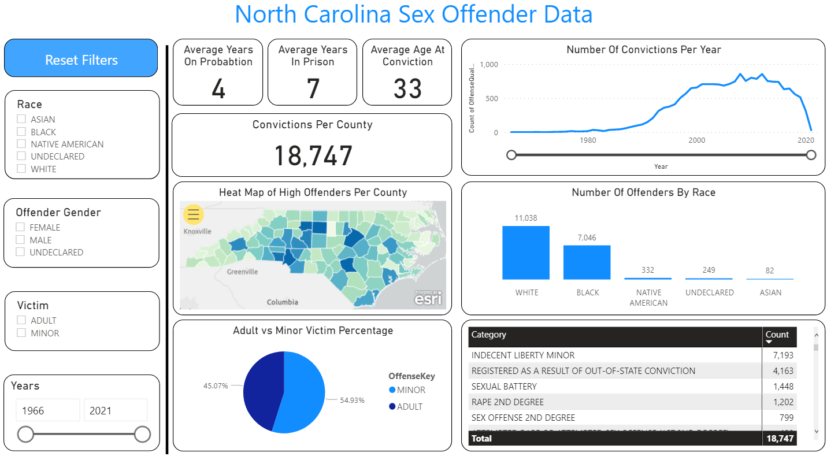

Figure 1-1: Shows the filters on the left side of the dashboard while visualizations are on the right.

The filters allow you to analyze data based on race, gender, adult/minor victim type, and year(s) of conviction Figure 1-2. The filters allow you to choose either one category or all four. For ease of use, a "Reset Filters" button was created to clear all filters on one click. Note, when in Power BI Desktop you will have to press "control" on your keyboard and then click the button, once posted to a dashboard, all you need to do is click the button.

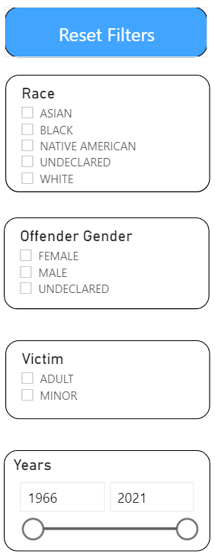

Figure 1-2: Filter Options.

Figure 1-3 allows you to analyze many different factors that can be found within the statewide registry. The visualizations include average years of probation, incarceration, and age of conviction.

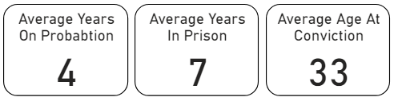

Figure 1-3: Illustrations of the averages

Figure 1-4 illustrates the number of convictions per county (1), heatmap of North Carolina (2), victim type percentage (3), number of convictions per year (4), number of offenders by race (5), and what the convictions are (6).

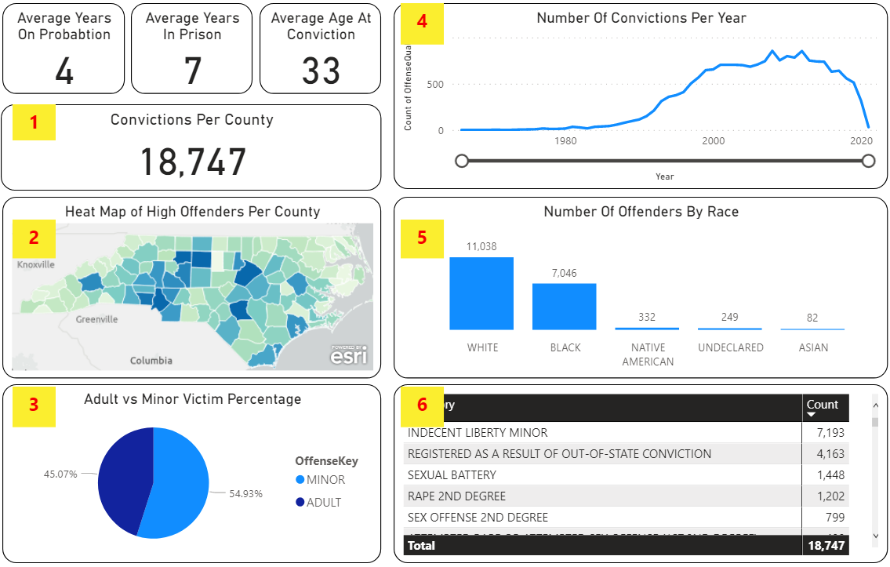

Figure 1-4: Visualizations by category

There are many ways to interact with the dashboard. All the filters effect every chart except for the heatmap and the number of offenders bar chart. I wanted to keep the number offenders by race constant so there are always shown and the heatmap allows you to hover over any county which allows you to see how many crimes were committed there.

As shown in Figure 1-1, there are four filter selections. However, the two I wanted to focus on were race and gender. I wanted to focus on race because there is a debate on the inequalities of the justice system. I also wanted to see the differences between the conviction rates of males versus females. Figure 1-5 depicts using a filter and choosing between races, you can select one or more at the same time. This example I chose to select is Asian; you can see how the numbers changed from Figure 1-1. The second example in Table 1-6 shows white offenders and ~~what~~ their statistics ~~are~~. You can see the Asian race stays on probation one year longer but stays in prison two years less. You will also see the differences in number of convictions, their trends by years, differences between offender types, and categories of crime offended.

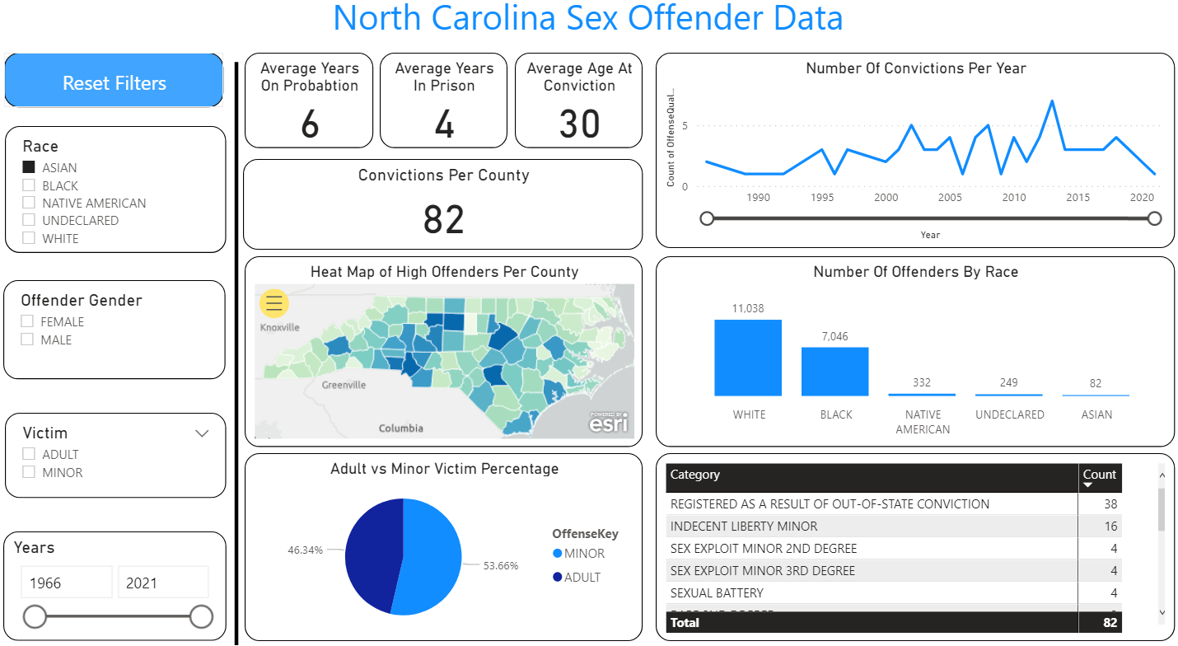

Figure 1-5: Visualizes the Asian Race

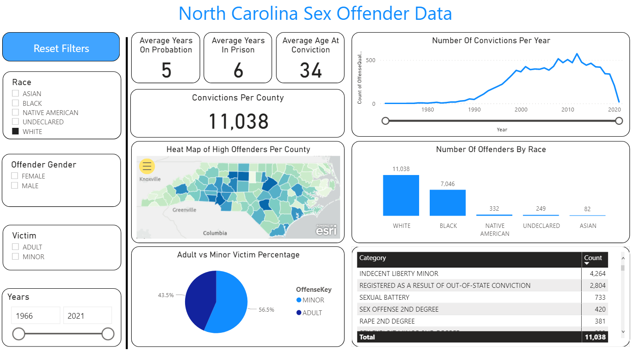

Figure 1-6: Visualizes the White Race

Figures 1-7 and 1-7 illustrates what happens when gender is added to the filter from Figure 1-6. You will see that white females stay on probation and/or in prison one year less than white males. The female offender tends to be two years younger and assaults minors more than their male counterpart.

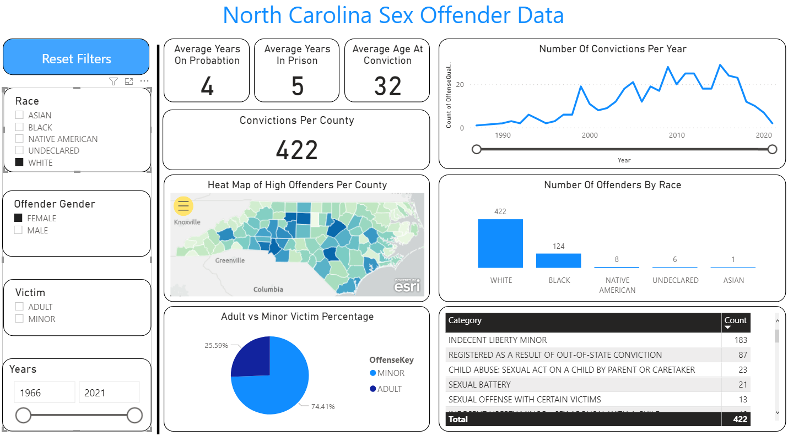

Figure 1-7

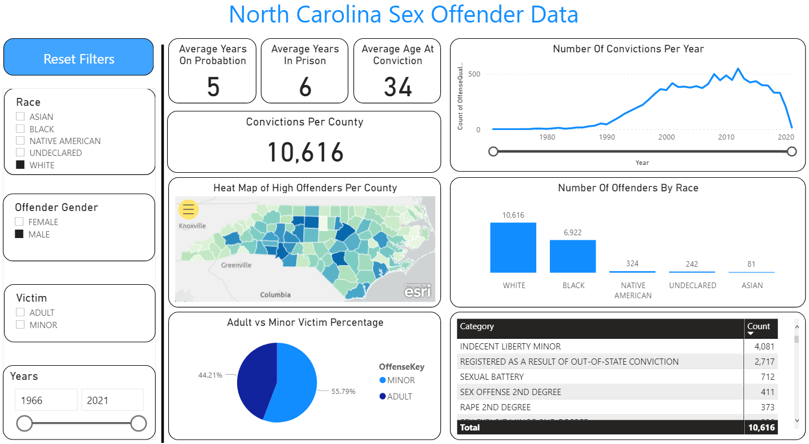

Figure 1-8

In summary, the North Carolina Sex Offender dashboard allows you to see the types of crimes committed, the average years of probation and prison, how many convictions per year, and highest concentration of offenders. The dashboard will allow you to analyze different statistics between races, genders, and victim types.

North Carolina Sex Offender and Public Protection Registry. (n.d.). Retrieved February 18,

2021, from <http://sexoffender.ncsbi.gov/stats.aspx>